Final Report
May 10, 2011

Web Air & Water Dispersion Model (WebAWDM)

Egg Men Industries
Cyle Lainson
Chad Ellsworth
Ryan Simmons

Table of Contents

I Team Overview | 1
II Problem Statement | 1
III Process Overview | 2
1 Project Management | 2
2 Design Methodology and Deliverables | 2
3 Timeline | 3
IV Requirements | 3
V Solution Statement | 5
1 Overall Solution and Functional Specifications | 5
2 Architecture Overview | 5
3 As-built Design | 7
VI Usability Testing and Future work | 10
1 Testing | 10
2 Future Work | 10
VII Conclusion | 11
VIII References | 11

I. Team Overview

We are Egg Men Industries, the capstone project team for the SCREEN3 Web Portal project. Our mentor was Dr. Li and our members and roles are as follows:

Cyle Lainson
  - Team Leader
    - Leads presentations and maintains schedule
  - Communicator
    - Handles communication with client, mentor, and any other external associates
Chad Ellsworth
  - Facilitator
    - Resolves any problems within the group
  - Document Coordinator
    - Writes first drafts of documents and maintains the guidelines
Ryan Simmons
  - Recorder
    - Writes weekly reports and maintains notes from meetings with mentor and client
  - Lead Researcher
    - Researches any needed information for the completion of the project

II. Problem Statement

Our sponsor, Dr. Terry Baxter, is an associate professor of Civil and Environmental Engineering at Northern Arizona University. From 1996 through 1998, Dr. Baxter managed an internship project associated with the National Atmospheric Release Advisory Center. During this project, atmospheric dispersion models were used to predict the dispersion of pollutants. However, these models could only be accessed from a single work station. This limited access led him to believe that a platform which would allow dispersion models to be utilized from any computer would be extremely useful, not only for professionals, but for educational purposes as well.

Dr. Baxter’s proposed solution was to create a web-based modeling program, using the basic SCREEN3 air dispersion model from the Environmental Protection Agency (EPA) as is, along with the necessary tools to add future models. The SCREEN3 program is old; with the last update being over 12 years ago; it has created compatibility problems with modern systems. The solution we were tasked to implement was to take the original system and create an interactive web application that allowed users to get results from multiple locations.

The SCREEN3 program is a widely used air dispersion model used to create a Gaussian plume model of a pollution source. This allows companies and environmental engineers the capability to track potential pollution from sources before they are created. For example, smoke stacks from a factory, or an area source such as a train yard. Companies can estimate pollution before beginning construction to ensure the structure abides by all local EPA clean air guidelines.

Unfortunately, the last update SCREEN3 has received was in 1996, making it unsuitable for anything other than a Windows 32-bit system. This presents a challenge as most modern systems are migrating to 64-bit. Fortunately, the EPA has released the source code of SCREEN3, allowing for further development to make the system more accessible.

With the source code readily available we were able to create a web portal to access the system externally. This allowed us to utilize SCREEN3’s reliability and gave us more opportunity to expand on the original requirements. The system is now compatible on every major operating system and is functional on all major browsers. We also added saving input data, graphing, administration tools, and the ability to import SCREEN3 input forms.

Applying the tools provided in our program, WebAWDM (Web Air & Water Dispersion Models), environmental engineers will be able to apply the SCREEN3 system in the field with their smart phone, save the input, access their data from any computer with internet access and then display their results. This attentiveness to convenience provides our system with portability and simplicity that is unmatched.

III. Process Overview

1. Project Management
Our system for decision making and reporting progress was a weekly meeting at 2:00 P.M. every Tuesday, along with a meeting with our mentor at 10:30 A.M. on Thursday. If necessary we would have additional meetings throughout the week to discuss implementation and work on deliverables and presentations.
At the weekly meeting with our mentor we would provide a weekly progress report. Included in the report were all current projects and their state of completion, along with any future plans for continuing development. This provided a method for viewing our progress and keeping on schedule for the finished application.

2. Design Methodology and Deliverables
We used a loose waterfall method to implement our project. This choice followed the structure of the course, with the mandatory deliverables of Requirements and Design documents. However, we would constantly consult with our client and rework the design throughout the implementation process as better methods and models were found. This provided us with all the elements of the waterfall method (Requirements, Design, Implementation, Verification, Maintenance), yet still provided the flexibility to utilize recently discovered tools.

The deliverables for this project are the Team Standards, Requirements and Execution Plan, Software Design Specification, and Final Report documents, in addition to the final finished product. Team Standards was the first document due, and it is where we decided the time and structure of our meetings, format of our documents, team roles, and how we would communicate with each other. The Requirements and Execution Plan codified our loose project goals into a list of requirements along with providing us a plan to carry out our project. Software Design Specifications defined our requirements into a design for the final project. This document is the Final Report.

3. Timeline

Figure 1: Timeline

Our initial project plan laid out in the Software Design Specifications document and final timeline are considerably different. We experienced setbacks with developing our website; we lacked a server to host the site, delaying our progress. However, we were able to make up for it by making a number of design decisions that shortened the time needed to build the project. One of these decisions was to use the already available Flot JavaScript library to generate the graphs. Another was using OpenID to authenticate users instead of creating our own system. In the end, we were able to finish the product on time with considerably better results than originally planned. A timeline of the progress we made is shown in Figure 1.

IV. Requirements

Drafting the requirements was a relatively simple process for us. Our client, Dr. Terry Baxter, was readily available to meet up with through scheduled meetings and during office hours in order to generate the requirements. One major change from the requirements was the removal of the subscriptions system. The funds generated from subscriptions would have been used to pay for server costs and future development; but the questionable legality of making a profit from a university project led us to abandon this feature.

We were to create a web application that houses the SCREEN3 program. It needed to be reliable, universally compatible, and user friendly. Furthermore, the system had to be well documented and modular to make future additions easy to handle. Finally, security was a main concern, as both the server and the users’ information needed to be well-protected.

1. General Tasks: Tasks which the system must perform effectively.
  - The program must be usable on the internet.
  - SCREEN3 must be able to be used to model input data.
  - Data must be able to be saved locally or on the server.
  - Users must be able to view data saved locally or on the server.

2. Security: Covers authentication and user/data management.
- Authentication
  - Users will need to authenticate their user status before being able to use the program.
- User Management
  - Administrators will be able to delete users, upgrade them to administrator status, and delete their saved input.

3. Modeling: Covers specific EPA models for use on the system.
- SCREEN3 needs to be incorporated into the system.
  - Any necessary information should be able to be entered into the SCREEN3 model, and the ASCII output generated by SCREEN3 should be available. There will further be an option to graph the data and save the input for later access.
- New models should be able to be easily added to the system.

4. Documentation
- System-Level Documentation
  - We document the entire project as a whole and explain what each individual piece does in broad terms.
- Code-Level Documentation
  - All code is fully documented. This includes comment blocks and method citations where needed.

5. Modular
- The system’s code needs to be broken up into logical sections, based on functionality, which can be edited without affecting other parts of the system.

6. Constraints
- Cross-Platform User Interface
  - The online interface should be accessible from all major browsers.
    - Internet Explorer, Google Chrome, Firefox, Opera, and Safari
  - The online interface should be accessible on all major operating systems.
    - Windows, Macintosh, and UNIX/Linux
  - The online interface should be accessible from smartphones with internet access
    - iPhones and Androids

V. Solution Statement

1. Overall Solution and Functional Specifications

Our solution came to be known as Web Air & Water Dispersion Models, or WebAWDM. It is a web application that acts as a conduit to the SCREEN3 model while providing an intuitive, dynamic entry form. Additional features, such as adding the ability to archive input data and graph a number of different aspects of the output data, are also included.

In order to make the system secure we initiated a username and password system using OpenID, a third party authentication system which accepts Google IDs and OpenIDs. Logging in is also required to use any of the functions of the site, such as using the input form and looking at saved data. An administrator system is in place which allows full control over the other users in the system.

The system is compatible with every major browser and operating system, notably Internet Explorer 6+ and iOS. IE6 doesn’t support CSS3 or HTML5, both modern tools utilized by Webstep. A number of workarounds were implemented to get the browser to display the site correctly despite our usage of Webstep. iOS, iPhone’s operating system, doesn’t support Flash, a common web tool for generating dynamic content. As such, we avoided any reliance on Flash in our website.

Finally, the system is very modular to allow for easy future development. When adding new models, none of the code needs to be changed in those models to make them function on our system; only input and output forms need to be created. Everything else can potentially be reused. Included to make this easier is extensive documentation throughout the code, along with an included developer’s manual.

2. Architecture Overview

This system consists of three main entities, as shown in Figure 2: the web application, the SCREEN3 modeling program, and the database. Figure 3 details the interactions between these entities.

The web application acts as the system’s user interface. This is where users will log into the system, employ the SCREEN3 model, access previously archived data, and graph the output. Along with general users, there is an additional administrator class of users which hold all the abilities of general users, along with the ability to access all user data with a limited ability to change it. Administrators will have the power to add or delete users, and also delete any archived data.

The SCREEN3 model takes in a .DAT file, which is generated from input data, and produces a text file containing ASCII output data. This data will be sent back to the web application, where
Figure 2: General Architecture

Figure 3: Connections

the user will be able to view it. Users also have the option of viewing a graphical representation of the data with the option to graph any of eight separate pieces of information.

The database holds all necessary data that needs to be saved for later use. This includes user names, archived input data, and whether the user is an admin. Administrators are able to manage the database through the web application using the admin page. However, only webmasters have direct database access.

3. As-built Design

This section will go briefly into every module of the final product and describe their general functions and interactions. For more specific details, please refer to the Developer’s Manual as provided on the capstone project website, at http://www.cefns.nau.edu/Research/D4P /EGR486/CS/11-Projects/SCREEN3/deliverables.html

The first major section is the Web Application. This section consists of 19 separate PHP files that all interact with at least one other file:

- home.php, aboutus.php, contact.php
  - These pages are purely information pages without any function except to provide information to the user about the product and our contact information. Users that are not logged in will only have access to the home.php, aboutus.php, contact.php, and menu.php
- archive.php, archive_actions.php
  - archive.php provides a table of archived data seen by the user. It interacts with the database to provide the user with their previously saved data and gives them the option through archive_actions.php to delete and load data.
- admin.php, remove_user.php
  - admin.php is only accessible by users who are currently tagged as users in the database and provides a table of users. Each user had a checkbox next to their name which, when selected, can be deleted through a button that activates the remove_user.php file. Each user is also a link that connects to the userpage.php page.
- userpage.php, make_admin.php
  - userpage.php provides the database information relevant to the user and provides a button to make that user an administrator through the make_admin.php file.
- menu.php
  - This page contains the code for the menu bar, which provides access to the information pages, webawdm.php, and, if the user is an admin, admin.php. It also includes login.php or loggedin.php, depending on whether the user is logged in or not.
- login.php, callback.php
  - login.php contains the Janrain Engine login widget. This widget sends users to callback.php upon a login attempt. callback.php authorizes the login attempt by accessing https://rpxnow.com/api/v2/auth_info. If the user is logging in for the first time their information is added to the database. Successful login will send the user back to home.php where content is generated based on the user’s credentials. If login is not successful the user will still be sent back to home.php where the user will be asked to try again.
- loggedin.php, logout.php
  - loggedin.php greets the user by their username and provides a link to logout.php, which logs the user out of the system by destroying the session and redirecting to home.php.

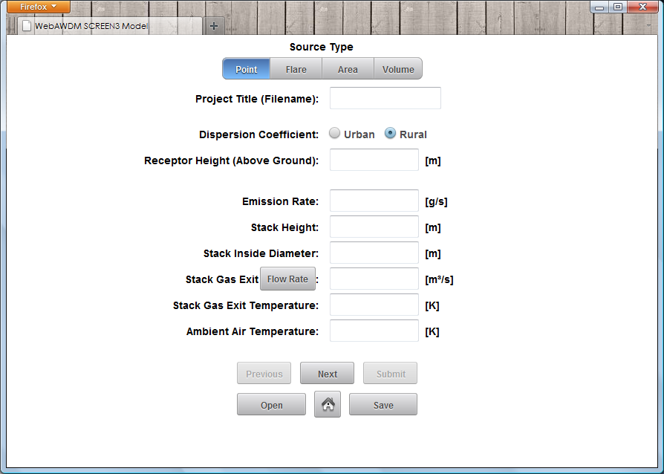
Figure 4: SCREEN3 Input Form

- webawdm.php, fileTransfer.php, fileSave.php
  - webawdm.php contains the SCREEN3 input form, the first page of which can be seen in Figure 4. Here users can input data, open saved data from their archive, save data to their archive, and submit data to be modeled by SCREEN3. The large input form is created using Webstep, a toolkit used for making rich internet applications. Once data inputting is finished, by clicking the submit button information is sent to fileTransfer.php. The code from fileTransfer.php places the information into a text file and sends it to run through SCREEN3, afterward redirecting the user to fileOutput.php. FileOutput.php displays the output information in text and graph form. The output is also stored as session data for use in graphing and saving to the user’s personal system. At anytime, the user can click the save button to save all current input data in the forms to the database using fileSave.php. The code from fileSave.php takes in a file name, input data, and source type and saves it to the database, afterwards redirecting the user back to webawdm.php.
- fileOutput.php
  - This page is in the form of a popup window, which contains the text output as held in session data from fileTransfer.php. It also contains a button to switch to graph.php at the bottom of the page
- graph.php
  - This page generates a dynamic graph using the tools provided by Flot, an open-source Javascript-based graphing toolkit. It uses the information provided by the output data to create a graph with a number of checkboxes which users can select and/or deselect, changing what information is graphed instantly.

The next section is the SCREEN3 system. This is provided by the EPA at http://www.epa.gov/ scram001/dispersion_screening.htm#screen3

When the SCREEN3 program is executed, the result outputted to the same directory, so as long as SCREEN3 was in the same folder as the rest of the program it works properly.

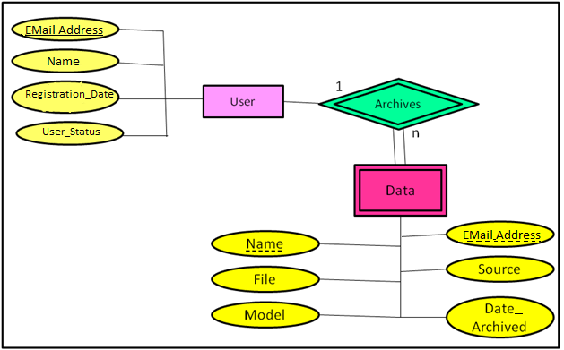
Figure 5: Entity-Relationship Diagram of WebAWDM’s Database

The final section is the database, the entity-relationship diagram of which can be seen in Figure 5. The database used by WebAWDM is a MySQL 5.5.8 database which contains two tables, “users” and “data”. “Users” stores the e-mail address, first name, registration date (date of first login), and user status of all users. “Data” stores the e-mail address of the user who archived each data set, as well as that set’s name, the data itself, the model and source used by that data, and the date it was archived. The “users” table utilizes e-mail address as a primary key, and the “data” table uses e-mail address and name in combination as a foreign key, where each name may only occur once per e-mail address, and every e-mail address present in the “data” table must also be present in the “users” table. One note of importance is that “Name” in the “users” table corresponds to the user’s first name, whereas “Name” in the data table corresponds to the file name, meaning the two have no relation to each other.

VI. Usability, Testing, and Future Work

1. Testing

Since our program is the union of many separate parts we needed to have section specific testing in addition to our overall use case testing. The different sections were the database, user authentication, login access, proper SCREEN3 output, graphing, saving input data, loading input data, and finally downloading and viewing output data.

Testing was done by inputting some use case scenarios created by us and provided by our client. More vigorous testing will be done by colleagues of our client who have agreed to use and test WebAWDM. The client also plans to use WebAWDM as a teaching tool in his class next semester. This will allow us to test the durability and reliability of WebAWDM in a real world scenario.

A use case scenario pertains to all actions possible by a user or admin in the WebAWDM system. Use case scenarios were generally simple situations in which a user might utilize our program. For instance, one case might be: logging in, loading input data, changing data, and then looking at the result. We tested for accuracy by comparing our application’s result with one of our competitor’s, Screen View by Lakes Environmental. While their program does not have web functionality our system provides, they do give the ability to input data into SCREEN3 and output a graph and an ASCII text file. We then compared our graph and text file to their result. After multiple different use cases using different browsers and operating systems, we were able to conclude that our program was accurate and precise no matter how it was accessed.

2. Future Work

From the start, our system had been created with expansion in mind. Some of the proposed expansions are:

- Newer Models
  - Adding newer more complex air dispersion models, such as AERSCREEN.
- Subscription
  - There is still talk of adding the subscription after the capstone is finished, so we can expect to see more details in the future
- Sharing data between users
  - Since the majority of users of this system will potentially be Environmental Engineers, it would be prudent to give them the ability to communicate results to one another

VII. Conclusion

In the end we were able to create a useful, intuitive product that satisfies every requirement, in addition to a few we added for convenience. WebAWDM has proven to be reliable, simple, portable system for interfacing with the SCREEN3 model, and, due to its modular design, we are certain it will perform well with other added models in the future. WebAWDM is a fantastic product which we are certain has only seen the beginning of a long future.

VIII. References

United States. Environmental Protection Agency. Screening Models.17 Aug. 2010. Accessed
17 Feb. 2011 <http://www.epa.gov/scram001/dispersion_screening.htm#screen3>.

“Screen View.” Lakes Environmental. 2011. Accessed 17 Feb. 2011
<http://www.weblakes.com/products/screen/index.html>.

